**IT2120 - Probability and Statistics**

**Lab Sheet 05**

**IT24100330**

**Exercise**

1.

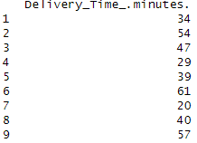

2.

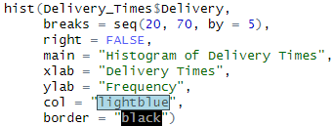





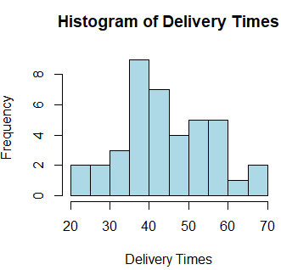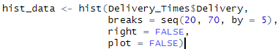3.

This is a Right-skewed distribution.

4.



